**Patrick McGill** 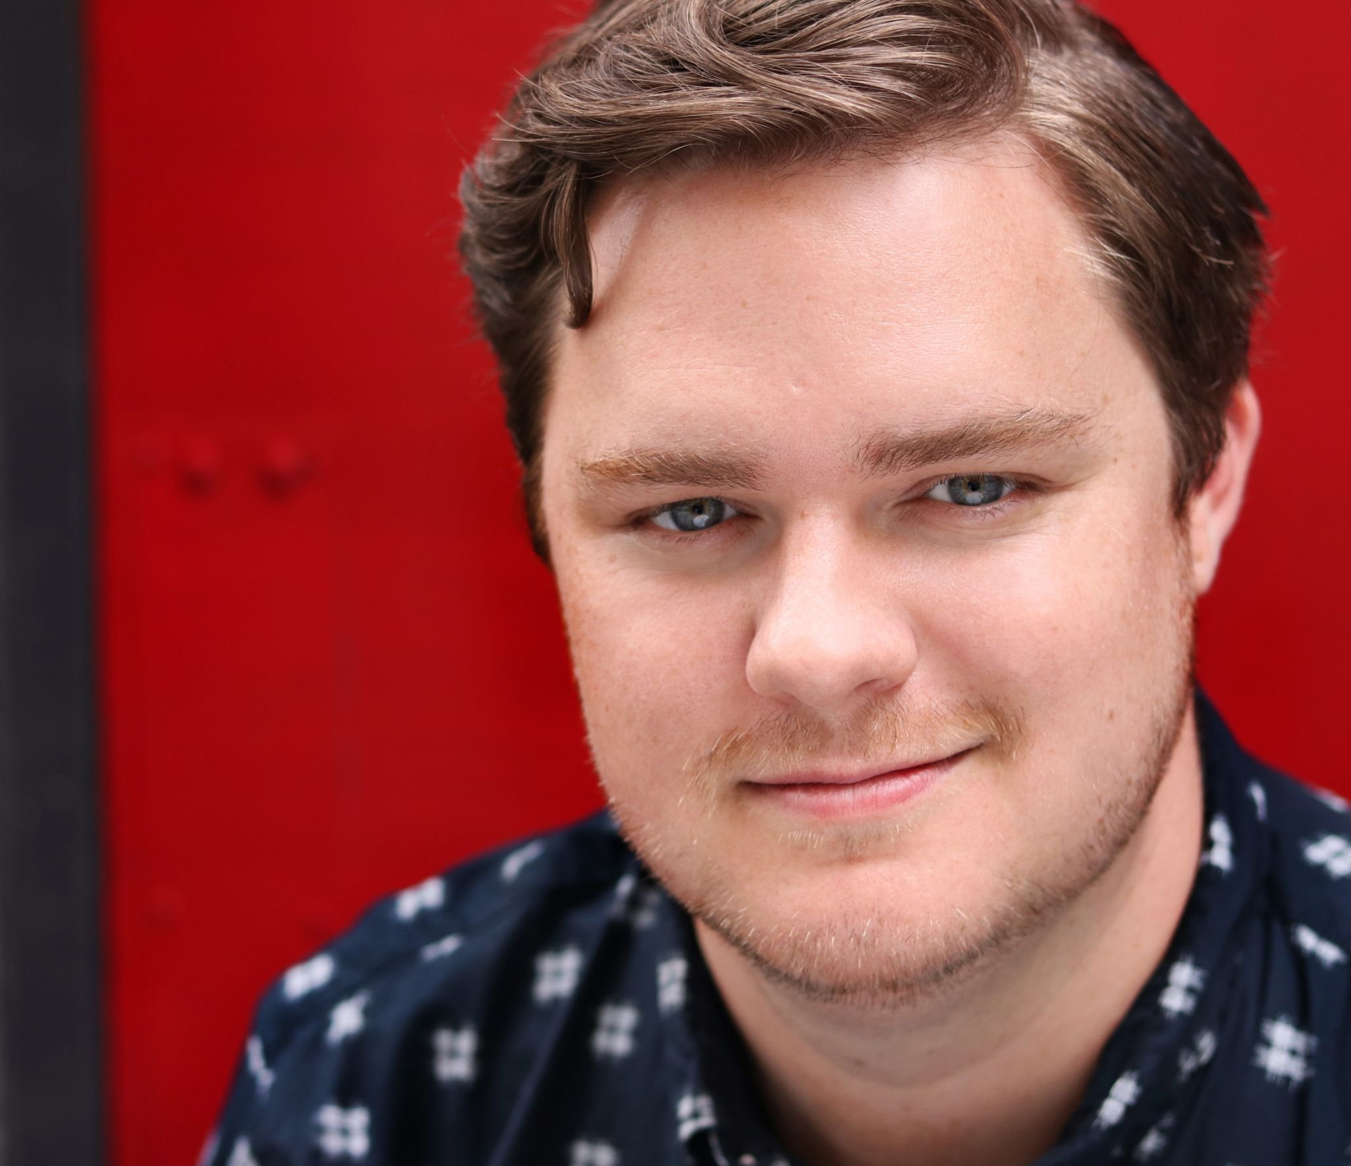

***Tenor***

(610) 812-6187

patrickmcgilltenor@gmail.com

41 Livingston St. New Haven, CT 06511

***Oratorio Experience***

**Tenor** **Soloist** Bethesda Lutheran Church *Bach BWV 33* 2022

**Tenor Soloist** German Concert Tour Yale/Juilliard *Haydn Schöpfungsmesse* 2022

**Tenor Soloist** Alice Tully Tall, Lincoln Center *Haydn Schöpfungsmesse* 2022

**Lecture Recital** Yale University  *Schubert’s Winterreise* 2022

**Tenor** **Soloist** Yale University *Bach Motets* 2021

**Tenor** **Soloist** *Bach BWV 42/211* Tanglewood Music Center 2019

***Ensemble Experience***

**Chorus** *Chemin de Noel* Chapelle de Quebec 2022

**Chorus** *Bach BWV 140, 109, 147* Chapelle de Quebec/Les Violons du Roy 2022

**Chorus** *Mozart Requiem* Chapelle de Quebec/NAC Orchestra 2022

**Chorus** *Byrd, Westin, Rheinberger, Holst* Yale Choral Artists 2022

**Chorus** Handel *Messiah* Les Violons du Roy & Chapelle de Québec 2021

**Chorus** *Haydn Lord Nelson Mass*  Orchestra of Saint Luke’s & Chapelle de Québec 2020

***Full Roles***

**Lucano** *L'incoronazione di Poppea* Berlin Opera Academy David Paul/Peter Leonard 2018

**Candide** *Candide* Banff: Opera in the 21st Century Joel Ivany/Topher Mokewzski 2018*

**Candide** *Candide* Opera McGill (Montreal, QC) Patrick Hansen/S. Hargreaves 2018*

**Normanno** *Lucia di Lammermoor* Opera McGill (Montreal, QC) Patrick Hansen/S. Hargreaves 2018

**Lurcanio** *Ariodante* Opera McGill (Montreal, QC) Aria Umezawa/H. Knox 2017

**Torquemada** *L’heure espagnole* Opera McGill (Montreal, QC) J. Patterson/O. Godin 2017

**Eisenstein** *Die Fledermaus* Opera McGill (Montreal, QC) Patrick Hansen 2017

**Oronte** *Alcina* Opera McGill (Montreal, QC) Patrick Hansen/H. Knox 2016 *

***Partial Roles***

**Peter Quint** *The Turn of the Screw* Banff: Opera in the 21st Century 2018

**Count Almaviva**  *Il barbiere di Siviglia* Banff: Opera in the 21st Century 2018

**Der Tenor** *Ariadne auf Naxos* McGill University 2016

**Nerone** *L'incoronazione di Poppea* McGill University 2016

***Educational Background***

MMA in Art Song, Oratorio, and Sacred Music, Yale University 2022

MM in Early Music Voice Performance, McGill University 2017

BM in Vocal Performance, The Boston Conservatory 2014

***Additional Educational Experience Awards***

Tanglewood Music Center Fellow Semifinalist, Elizabeth Wirth Vocal Excellence Competition 2016/17

Banff: Opera in the 21 Century Second Place, NEMPAC Undergraduate Competition 2014

***Principal Vocal Studies*** ***Coaches*** ***Masterclasses***

James Taylor Stephen Hargreaves Renee Fleming

John Mac Master (McGill University) Michael McMahon Stephanie Blythe (* indicates cover.)